Welcome to USU Data Analytics!

Follow the instructions below to get set up. We’re excited to have you!

Install Git:

1. Download Git
   1. For Mac users:
      1. Google “download Git for mac”
      2. The web address is: <https://git-scm.com/download/win>
   2. For Windows users:
      1. Google “download Git for windows”
      2. The web address is: <https://git-scm.com/download/mac>
2. Tell Git your name and email address. These are used to label each commit so that when you start collaborating with others, it’s clear who made each change. In the shell, run:

**git** config --global user.name "YOUR FULL NAME"

**git** config --global user.email "YOUR EMAIL ADDRESS"

(You can check if you’re set up correctly by running git config --global --list in the git Bash console.)

1. Restart R if R was already open.

Directions for GitHub:

1. Create a GitHub account
   1. Go to GitHub’s website
      1. <https://github.com/>
   2. Enter a username, email (same as above), and password to create your account.
2. Get added to the USUDataAnalytics GitHub repository
   1. Send an email request to [USUDataAnalytics@gmail.com](mailto:USUDataAnalytics@gmail.com), or ask a presidency member.

Making contributions to the GitHub repository:

1. Go to the USUDataAnalytics repository on GitHub
   1. Make a branch off of the master
      1. 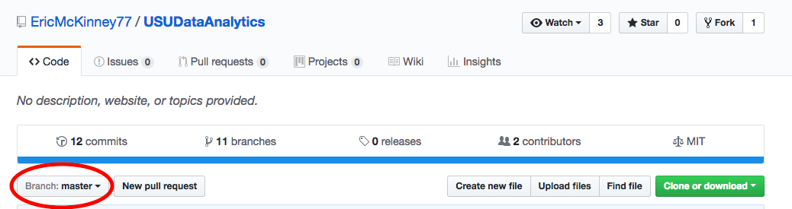Click on the “Branch:master” tab
      2. Enter the name of the new branch you would like to create.

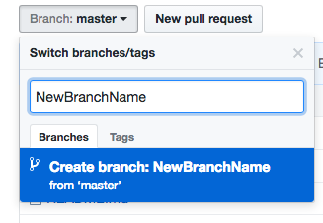

1. 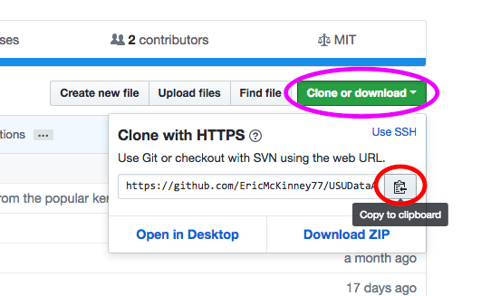Opening the branch in R
   1. First click “Clone or download”, and copy the link to the clipboard (we’ll need it in a minute)
   2. Once copied, go to R. Click File 🡪 New Project…

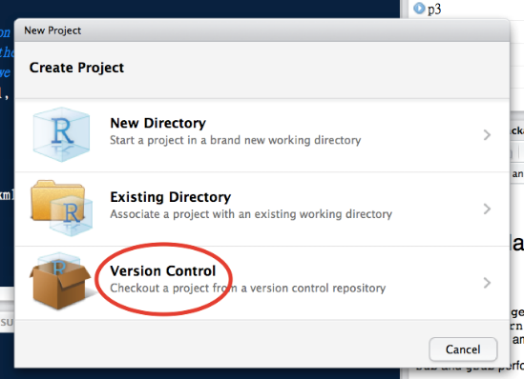

* 1. The following window will pop up. Click “Version Control”.

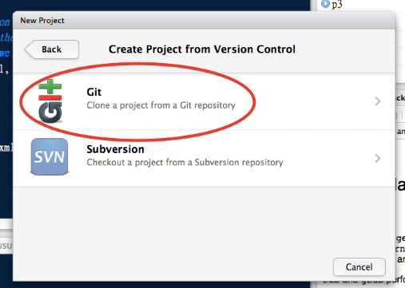

* 1. It will go to the following window. Click “Git”
  2. In the URL box, paste in the link we had copied before.
  3. Then create the project!

1. Using the Repository (aka: pushing and pulling)
   1. There is a “Git” tab now on the top right of your screen. This contains the information in the repository.

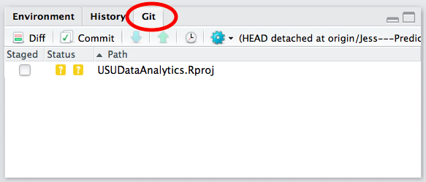

* 1. Click on “master” to view a dropdown menu of all local (on your computer) and remote (on GitHub) branches. **Change the branch to be whatever you named your new branch!** This will avoid making changes to the master branch of code)

1. Make contributions to the code
   1. Explore your local version of the repository 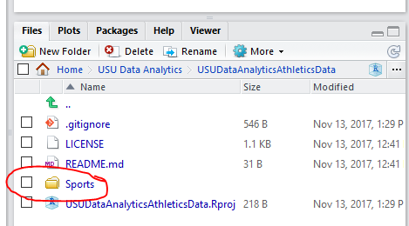

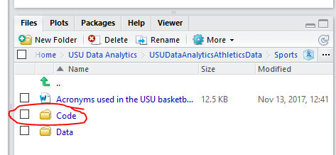 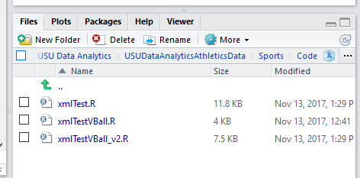

* 1. Open an R script (or other associated R file like an .Rmd file).
  2. Make contributions

1. Pushing changes to the remote branch
   1. Save your work to your computer. You will see modified documents appear under the Git tab. Click the Commit button. **Make sure you are not on master!**

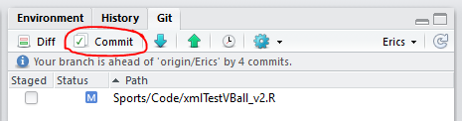

* 1. A new window appears. Check all modified code (stage your changes) you want to push to the GitHub branch. Proposed changes display below. Add a commit message (focus on the WHY of the change instead of the WHAT). Click Commit.

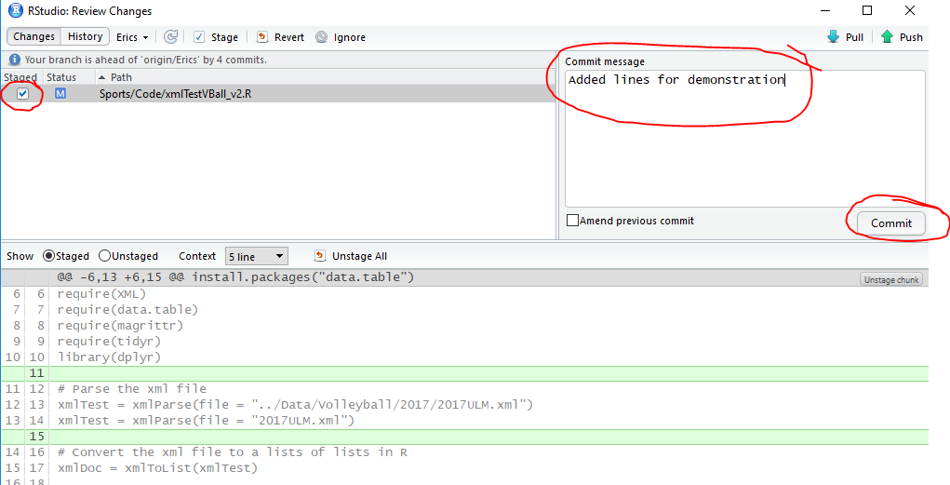

* 1. Push changes to the Remote Branch. Your changes are now saved to your GitHub branch.

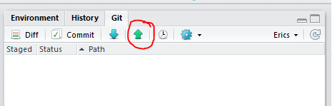

1. Propose a Pull-Request
   1. Go to GitHub
   2. Make sure you are on your Remote Branch. Click Compare & pull request.

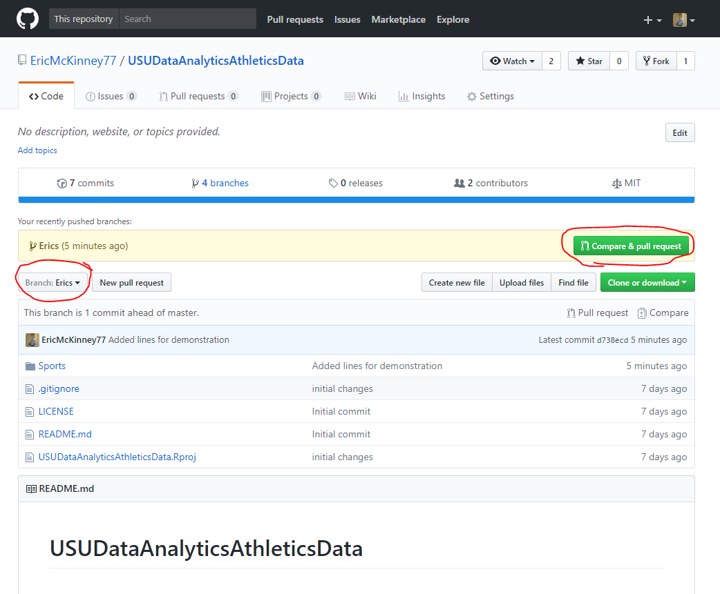

* 1. Comment if necessary, and click Create pull request.

1. From here a presidency member will approve pull requests to be merged with the master branch. Now your contributions can be used by all members!

A few things to know about Git

* Don’t worry about .gitignore in the files in the repository
* Know the Git is a public repository – there is a fee for not sharing code.

Joining the Kaggle competition & USUDataAnalytics Team

1. Create a Kaggle account.
2. Click the “Competitions” tab on the top of the page.
3. Scroll down to find our current competition, and click on it (ask a presidency member if unsure which competition).
4. Click “Join Competition” our current competition, then refresh your page.
5. In the competition, a new “Team” tab should appear – click on it.
6. On the page find where it says “Team Name”
7. Send this name to USUDataAnalytics@gmail.com – a presidency member will invite you to join the USUDataAnalytics team.